**Git and GITHub**

**Create a new repository**

Create a new directory, open it and perform a   
git init  
to create a new git repository.

## Checkout a repository

Create a working copy of a local repository by running the command  
git clone /path/to/repository  
when using a remote server, your command will be  
git clone username@host:/path/to/repository

**Workflow**

Your local repository consists of three "trees" maintained by git. the first one is your Working Directory which holds the actual files. The second one is the Index which acts as a staging area and finally the HEAD which points to the last commit you've made.

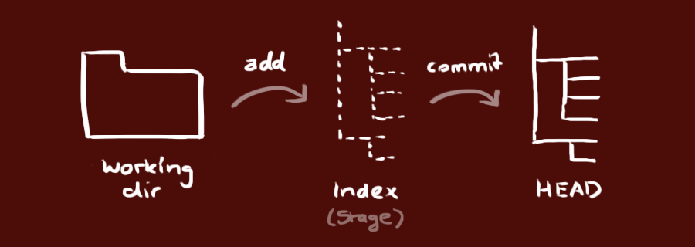

## Add & commit

You can propose changes (add it to the **Index**) using  
git add <filename>  
git add *  
this is the first step in the basic git workflow. To actually commit these changes use  
git commit -m "Commit message"  
Now the file is committed to the **HEAD**, but not in your remote repository yet.

## Pushing changes

Your changes are now in the **HEAD** of your local working copy. To send those changes to your remote repository, execute   
git push origin master  
Change *master* to whatever branch you want to push your changes to.   
  
If you have not cloned an existing repository and want to connect your repository to a remote server, you need to add it with  
git remote add origin <server>  
Now you are able to push your changes to the selected remote server

**Branching**

Branches are used to develop features isolated from each other. The *master* branch is the "default" branch when you create a repository. Use other branches for development and merge them back to the master branch upon completion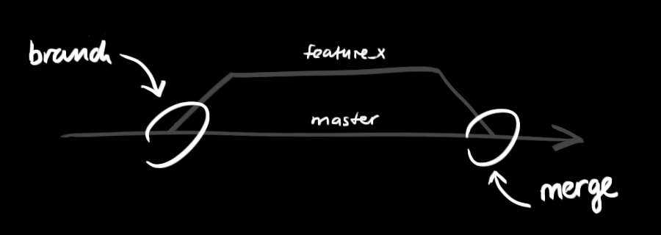n

Create a new branch named "feature_x" and switch to it using

git checkout -b feature_x

Switch back to master

git checkout master

delete the branch again

git branch -d feature_x

a branch is *not available to others* unless you push the branch to your remote repository  
git push origin <branch>

## Update & merge

to update your local repository to the newest commit, execute   
git pull

in your working directory to *fetch* and *merge* remote changes.  
to merge another branch into your active branch (e.g. master), use  
git merge <branch>

in both cases git tries to auto-merge changes. Unfortunately, this is not always possible and results in *conflicts*. You are responsible to merge those *conflicts* manually by editing the files shown by git. After changing, you need to mark them as merged with  
git add <filename>

before merging changes, you can also preview them by using  
git diff <source_branch> <target_branch>

## Log

In its simplest form, you can study repository history using.. git log  
You can add a lot of parameters to make the log look like what you want. To see only the commits of a certain author:  
git log --author=bob  
To see a very compressed log where each commit is one line:  
git log --pretty=oneline  
Or maybe you want to see an ASCII art tree of all the branches, decorated with the names of tags and branches:   
git log --graph --oneline --decorate --all  
See only which files have changed:   
git log --name-status  
These are just a few of the possible parameters you can use. For more, see git log --help

## Replace local changes

In case you did something wrong, which for sure never happens ;), you can replace local changes using the command  
git checkout -- <filename>  
this replaces the changes in your working tree with the last content in HEAD. Changes already added to the index, as well as new files, will be kept.

If you instead want to drop all your local changes and commits, fetch the latest history from the server and point your local master branch at it like this  
git fetch origin  
git reset --hard origin/master